12th Workshop on Two-Phase Flow Predictions - Test Case Description

Benchmark test on particle-laden channel flow
with point-particle LES

C. Marchioli, A. Soldati (University of Udine, Italy)
J.G.M. Kuerten (Technische Universiteit Eindhoven, Netherlands)

1. MOTIVATION:

The objectives of this benchmark calculation are
- to have a large number of people carrying out large-eddy simulations of the same specific problem with different numerical methods and subgrid models;
- estimation of quality of LES through comparison with a DNS dataset previously obtained for the same flow configuration [1] (http://cfd.cineca.it/cfd/repository).
To these objectives, synchronized activity among participants are required.

2. PARAMETERS OF THE BENCHMARK SIMULATION:

2.1 Fluid:

Shear Reynolds number (Re_{τ})¹ | Shear velocity (u_{τ}) | Density (ρ) | Kinematic viscosity (ν)
150 | 0.11775 m/s | 1.3 kg/m³ | 1.57 10⁻⁵ m²/s
¹Shear Reynolds number: Re_{τ}= u_{τ} h/ν with h =half channel height (see sketch below).

Note: all variables are made dimensionless (in wall units, identified by the superscript +) using u_{τ} and ν.

- Physical flow domain:
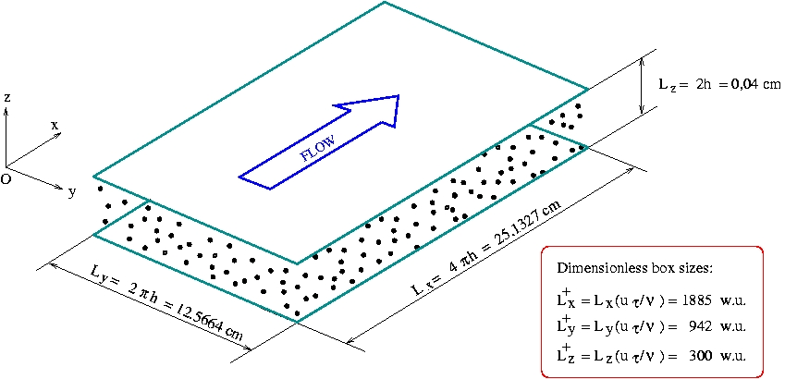

- Computational domain:
(i) Grid: N_{x} x N_{y} x N_{z} = 64 x 64 x 64/65 nodes ;
(ii) Boundary Conditions: periodicity in x and y, no slip at the walls.

2.2 Particles:

- Particles are assumed to be pointwise, rigid and spherical.
- Density: ρ_{p} = 1000 kg/m³ (-> ρ_{p} /ρ = 769.23).
- One-way coupling between fluid and particles.
- Only drag force in the particle motion equations.
- No SGS model in the particle motion equation.
- Initial conditions for Lagrangian particle tracking: tracking is started in the fully-developed statistically-stationary fluid flow regime. Initially, particles are homo-geneously distributed over the entire computational domain.
- Boundary conditions for particles: elastic collisions at the wall, periodic conditions in the streamwise and spanwise direction.

Dimensionless Stokes number (St)² | Number of tracked particles (Np) | Average volume fraction (ΦV) | Average mass fraction (ΦM)
1 | > 100000 | > 3.52 10⁻⁸ | > 2.35 10⁻⁴
5 | > 100000 | > 3.93 10⁻⁶ | > 3.02 10⁻³
25 | > 100000 | > 4.40 10⁻⁵ | > 3.38 10⁻²
² Stokes number: St = τ_{p} / τf with τf = u²_{τ} / ν.

3. GUIDELINES FOR PARTICIPANTS:

3.1 Simulations

Participants asked to fulfill the following steps:
- Reproduce coarse DNS of particle-laden turbulent channel flow using the parameters provided in Section 2 (no SGS model in the fluid flow equations).
- Reproduce LES of particle-laden turbulent channel flow using the parameters provided in Section 2. Use an eddy-viscosity SGS model for the fluid equations (either the Smagorinsky model with wall damping or a variant of the dynamic eddy-viscosity model).
- For particle tracking in simulations at steps 1 and 2 both tri-linear and a higher order interpolation should be used.

3.2 Required quantities

In order to be able to compare the results at least the following quantities should be provided. All quantities should be given in wall units and for particle concentration scaled with the initial particle concentration and all quantities should be averaged over sufficiently long time.
- Mean, root mean square, skewness and flatness of all fluid velocity components, fluid
Reynolds stresses. Do not include subgrid contributions to these fluid properties!
- Mean relative velocity in the wall-normal direction. This quantity is stationary after a
small initial transient in the DNS.
- Mean, root mean square, skewness and flatness of all particle velocity components, particle Reynolds stresses.
- Mean, root mean square, skewness and flatness of fluid velocity components at the particle location, particle Reynolds stresses.
- Average particle concentration in the steady state.
Particle concentrations should be given for a hyperbolic tangent bin distribution. The
dividing points of the bins are given by:
x_{j} = Re_{τ} [tanh(Δ (j_{max} − j )/j_{max})/ tanh(Δ )]
for j = 0, 1, . . . , j_{max} , where x₀ is the point on the wall and x_{jmax} is the point at the
center of the channel. Set j_{max} = 96 and Δ= 1.7.
Note: fluid and particle velocity statistics can be given on an arbitrary division of points.

3.3 References

[1] C. Marchioli, A. Soldati, J.G.M. Kuertenb, B. Arcen, A. Tanière, G. Goldensoph, K.D. Squires, M.F. Cargnelutti and L.M. Portela, Statistics of particle dispersion in direct numerical simulations of wall-bounded turbulence: Results of an international collaborative benchmark test, Int. J. Multiphase Flow 34(9), 2008: 879-893.

